**Execution Screenshots of the Form1 (Solution – ‘InClass’)**

1. On Clicking the Start button in Visual Studio, the below screen appears with the first row from the database.

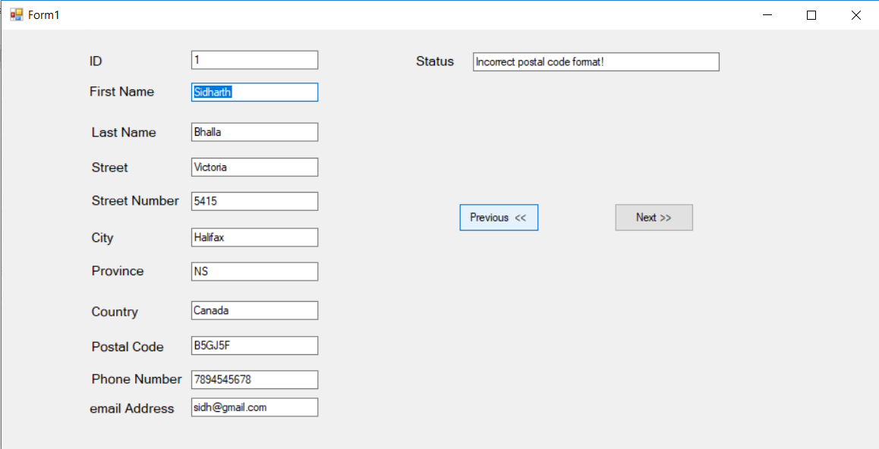

1. On Clicking the below highlighted Previous button, the Status textbox displays the message – First row reached in Customer Database.

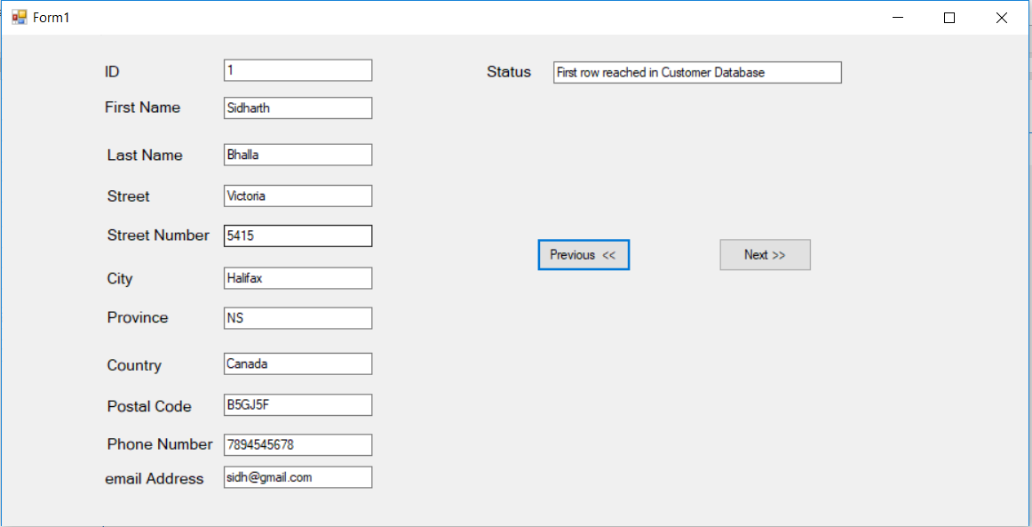

1. On Clicking the highlighted Next button, the next row of database appears with the relevant status in the status textbox.

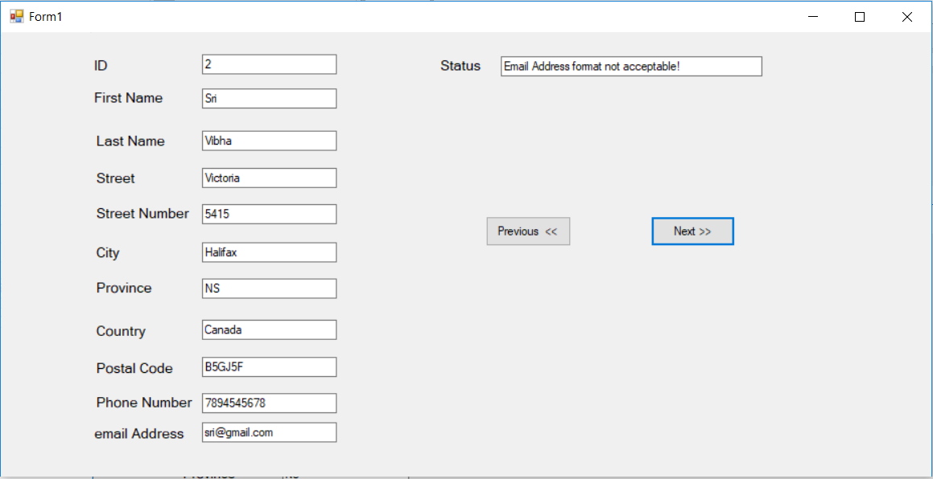

1. On Clicking the highlighted Next button, the next row of database appears with the relevant status in the status textbox.

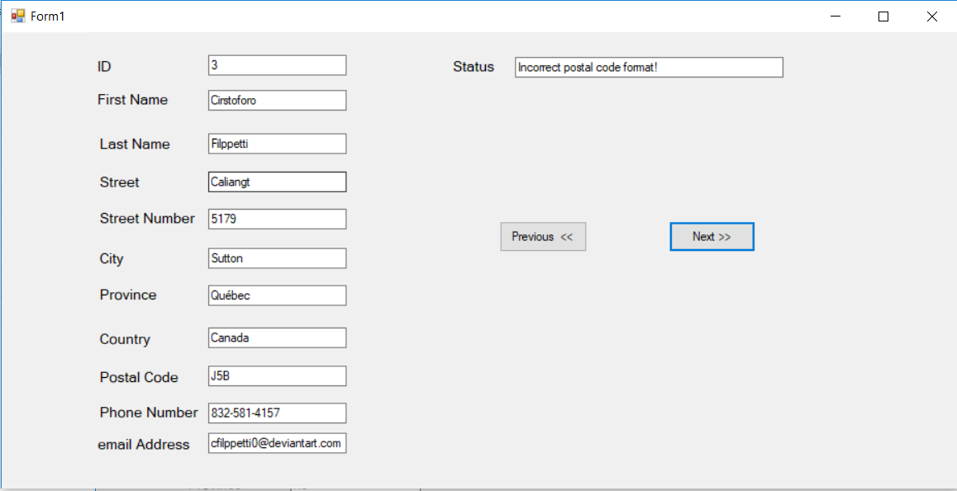

1. On Clicking the highlighted Next button 3 more times, the 6th row of database appears with status textbox empty since postal code, phone number and email address are acceptable.

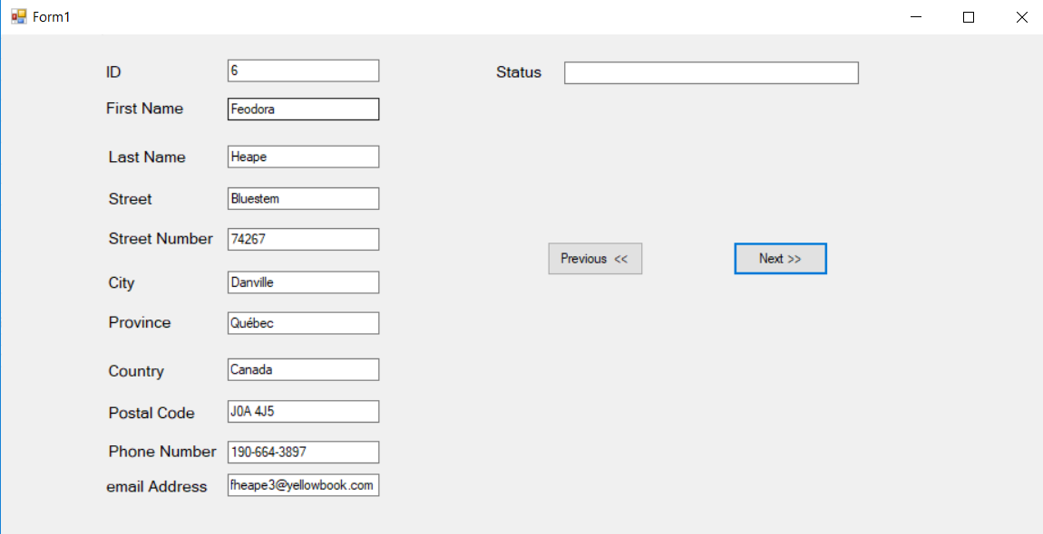

1. On Clicking the highlighted Next button, the last row of database appears with the relevant status in the status textbox – Last row reached in Customer Database.

